

GUILDWARS 2 Skyscale Guide

The how to get it for the Skyscale mount

By Lexa Km Trikru AKA Larissa

guardian of the united[gotu] (leader)  EU based

REQUIREMENTS:

* Path of Fire
* All Living world **4** episodes (**4** & **6** Finished) rest 1st mission to unlock maps
* Mounts : *Raptor*, *Springer*, *Jackal*, *Skimmer* (*Griffon* is handy for faster progress)
* In Map Dragon fall **10** events each of all **3** areas completed to unlock the merchants
* Minimum time to complete = **1** week
* **IMPORTANT**: **2** hour wait time until next collection unlocks (Total **5** Primary Collections existing out of smaller collections)

the smaller ones don’t include wait time)

INDEX

Intro [Requirements Skyscale] page- 1,2,3

Collection 1 [Newborn Skyscales] page- 4,5

Collection 2 [Saving Skyscales] page- 6,7,8

Collection 3 [Raising Skyscales] page- 9

Collection 4 [Troublesome Skyscales] page- 10

Collection 5 [Riding Skyscales] page- 11

***!!!Do Collect All these things on Pages 1,2,3 while not in the progress yet or already in it because some are time stealing!!***

|  |  |
| --- | --- |
| +- **5390** Karma | Complete Events etc. (use Karma Boosters) |
| +- **1700** Volatile Magic | Events (*Dragonfall*, *Thunderhead* *Peaks*, *Domain* o*f* *Istan*, *Domain of Kourna, Jahai Bluffs*, *Sandswept Isles*. Also harvest ores etc. |
| **520** Elonian Trade Contracts | Events *Crystal* *Desert*, sand piles, trade caches etc. |
| **260** Mistborn Motes | Events *Dragonfall* + harvest the nodes + Map completion per character **25** + Daily Heart **5** each + Volatile magic Trader *Dragonfall* **5** Per day  *Bjora* Currency (7**5** ice shards for **10** Mistborn Motes) |
| **250** Kralkatite Ores | Events *Domain of Istan* + Harvest nodes + Map completion per character **25** + Daily Heart **5** each + Volatile magic Trader *Dragonfall* **5** Per day  *Bjora* Currency (7**5** ice shards for **25** Kralkatite Ore) (easy harvesting *Domain* *of* *Istan*) |
| **250** Difluorite Crystals | Events *Sandswept* *Isles* + Harvest nodes + Map completion per character **25** + Daily Heart **5** each + Volatile magic Trader *Dragonfall* **5** Per day  *Bjora* Currency (7**5** ice shards for **10** Difluorite Crystals) (easy harvesting *Sandswept* *Isles*) |
| **250** Inscribed Shards | Events *Domain* *of* *Kourna*+ Harvest nodes + Map completion per character **25** + Daily Heart **5** each + Volatile magic Trader *Dragonfall* **5** Per day  *Bjora* Currency (7**5** ice shards for **10** Inscribed Shards) |
| **250** Mistonium | Events *Jahai* *Bluffs* + Harvest nodes + Map completion per character **25** + Daily Heart **5** each + Volatile magic Trader *Dragonfall* **5** Per day  *Bjora* Currency (7**5** ice shards for **10** Mistonium) |
| **250** Branded Masses | Events *Thunderhead* *Peaks* + Harvest nodes + Map completion per character **25** + Daily Heart **5** each + Volatile magic Trader *Dragonfall* **5** Per day  *Bjora* Currency (7**5** ice shards for **10** Branded Masses) |
| **12** Pieces of Skyscale Food | Mystic Forge (no limit) each / total  **2** / **24**  -  [Slab of Red Meat](https://wiki.guildwars2.com/wiki/Red_Meat)  **1** / **12**  -  [Charged Quartz Crystal](https://wiki.guildwars2.com/wiki/Charged_Quartz_Crystal)  **5** / **60**  -  [Glob of Ectoplasm](https://wiki.guildwars2.com/wiki/Glob_of_Ectoplasm)  **25** / **300**   - [Pile of Bloodstone Dust](https://wiki.guildwars2.com/wiki/Bloodstone_Dust) |
| **1** Grow Lamp | If cant craft make a deal with someone who can or buy Trading Post +- 4**0** gold  Crafting: ***JEWELER (400 Rank)*** total  **10**  -  [Charged Quartz Crystal](https://wiki.guildwars2.com/wiki/Charged_Quartz_Crystal)  **10**  -  [Orichalcum Setting](https://wiki.guildwars2.com/wiki/Orichalcum_Setting)  **25**  -  [Sunstone Lump](https://wiki.guildwars2.com/wiki/Sunstone_Lump)  **25**  -  [Watchwork Sprocket](https://wiki.guildwars2.com/wiki/Watchwork_Sprocket) |
| [Gold coin](https://wiki.guildwars2.com/wiki/Coin) **41** gold (optional excluded) | Speaks for itself (Ask around for fast ways getting gold) |
| 22 Charged Quartz Crystals (Optional exluded) | Exchange **25**  Quartz Crystals at place of power each day to get more:  <https://wiki.guildwars2.com/wiki/Place_of_power> |
| 1 Extra-Punged Skyscale Treat | Faster Completion = **11** (**1** for free at start collection) craft it or buy via trading post +- **7** gold  Crafting: ***CHEF (300 rank***) each / total  **1** / **11**  -  [Smell-Enhancing Culture](https://wiki.guildwars2.com/wiki/Smell-Enhancing_Culture)  **1** / **11**  -  [Charged Quartz Crystal](https://wiki.guildwars2.com/wiki/Charged_Quartz_Crystal)  **2** / **22**  -  [Slab of Red Meat](https://wiki.guildwars2.com/wiki/Red_Meat)  **10** / **110**  -  [Pile of Bloodstone Dust](https://wiki.guildwars2.com/wiki/Bloodstone_Dust) |
|  |  |
|  |  |

Collection 1 [Newborn Skyscales]

After completing living world episodes 4 [A Star To Guide Us {Legacy} To unlock sunspears refuge] + 6 [War Eternal] you get mail from Gorrik to see him

* **Skyscale scales:** 
  + Talk to Gorrik to get collections (At *Dragonfall* Near Skyscale’s Earie Point of Interest)
  + Collect Scales around *Dragonfall* **(**[**https://wiki.guildwars2.com/wiki/Skyscale_Scales**](https://wiki.guildwars2.com/wiki/Skyscale_Scales)**)** for the locations
  + Talk To Gorrik Again
* **Skyscale Medicine:**
  + [](https://wiki.guildwars2.com/wiki/Activated-Charcoal_Paste) [**Activated-Charcoal Paste**](https://wiki.guildwars2.com/wiki/Activated-Charcoal_Paste)
    - Complete 10 Events in *Dragonfall* (Left Upper Section) to unlock the Blooming Crystal Quartermaster (4,900  Karma to buy).
      * Achievement called *Putting Out Fires*
  + [](https://wiki.guildwars2.com/wiki/Gravewort_Paste) [**Gravewort Paste**](https://wiki.guildwars2.com/wiki/Gravewort_Paste)
    - Complete 10 Events in *Dragonfall* (Left Lower Section) to unlock the Olmakhan Quartermaster (100 [](https://wiki.guildwars2.com/wiki/Volatile_Magic)Volatile Magic + 5[](https://wiki.guildwars2.com/wiki/Mistborn_Mote) Mistborn Motes to buy).
      * Achievement called *Life In The Underworld*
  + [](https://wiki.guildwars2.com/wiki/Mashed_Echinacea) [**Mashed Echinacea**](https://wiki.guildwars2.com/wiki/Mashed_Echinacea)
    - Complete 10 Events in *Dragonfall* (Green Section) to unlock the Mist Warden Quartermaster (100 [](https://wiki.guildwars2.com/wiki/Volatile_Magic)Volatile Magic + 5[](https://wiki.guildwars2.com/wiki/Mistborn_Mote) Mistborn Motes to buy).
      * Achievement called *Cutting Weeds*
  + [](https://wiki.guildwars2.com/wiki/Stabilized_Brandstorm_Flux) [**Stabilized Brandstorm Flux**](https://wiki.guildwars2.com/wiki/Stabilized_Brandstorm_Flux)
    - Traveling Elonian Trader at the Pact Command *Dragonfall* (245  Karma + 10 [](https://wiki.guildwars2.com/wiki/Trade_Contract) Elonian Trade Contracts to buy).
  + [](https://wiki.guildwars2.com/wiki/Tincture_of_Volatile_Magic) [**Tincture of Volatile Magic**](https://wiki.guildwars2.com/wiki/Tincture_of_Volatile_Magic)
    - Traveling Elonian Trader at the Pact Command *Dragonfall*

(245  Karma + 10 [](https://wiki.guildwars2.com/wiki/Trade_Contract) Elonian Trade Contracts to buy).

* + Talk To Gorrik Again
* **Skyscale Fever:**
  + Feed the medicine to the Skyscales hidden around *Dragonfall*

(<https://wiki.guildwars2.com/wiki/Skyscale_Fever>) for the locations

* + Talk To Gorrik Again
* **Skyscale Eggs:**
  + Find the Skyscale Eggs spread through *Dragonfall*

(<https://wiki.guildwars2.com/wiki/Skyscale_Eggs>)

* + Talk to Gorrik Again (this will activate the 2 hour timer until can start next collection which will be notified via mail)

Collection 2 [Saving Skyscales]

Check mail for the invitation, go to him at same location in *Dragonfall*

***DOMAIN OF VABBI Star Marked Objectives much same map unlock this first:***

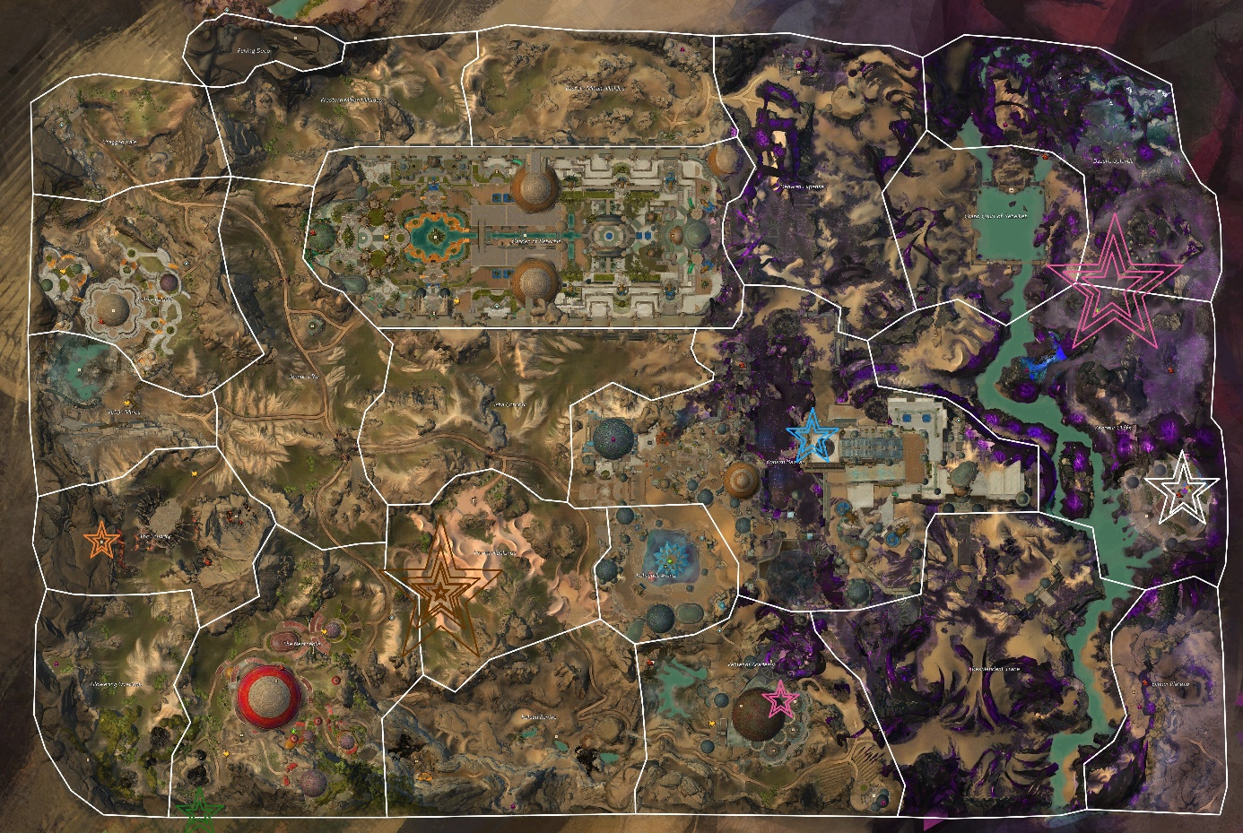

* **Skyscale of Water: Domain of Vabbi To Unlock (Kill Foes to draw Djinn Out white star)**
  + Swim down to the bottom of the Flooded Castavall in Bloodtide Coast ( Castavall Waypoint)
  + Swim in the water at the dwarven ruins in Desert Highlands (need video for that : (<https://www.youtube.com/watch?v=vzBT98Lg424>)
  + Swim to the bottom of the Ntouka Pond in Domain of Kourna
* **Skyscale of Fire: Domain of Vabbi To Unlock (Kill Foes to draw Djinn Out white star)**
  + Get burned by lava in domain of Vabbi (Check Map Vabbi Here Marked with this Color Star)
  + Get burned by lava of the Great Imperial Shelter in Black Citadel
  + Get burned by lava in the volcano in Mount Maelstrom
  + Jump Down In Lava at the Dwarven ruins (snow section) in Desert Highlands
* **Skyscale of Death: Domain of Vabbi To Unlock (Kill Foes to draw Djinn Out white star)**
  + Speak with sister Lissa at the Hero Point near [](https://wiki.guildwars2.com/wiki/Waypoint)Necropolis Waypoint
  + Visit the Dead at Field of the Hopeful near [](https://wiki.guildwars2.com/wiki/Waypoint)Champion’s Dawn Waypoint in Domain of Istan
  + Visit the Dead at Exile’s Rest near [](https://wiki.guildwars2.com/wiki/Waypoint)Olishar’s Oasis Camp Waypoint in Elon Riverlands
  + Visit the Dead at The Bone Palace during the event in Elon Riverlands
  + Visit the Dead at The Tomb of Primeval Kings near Lommuld Kraal Waypoint in Desert Highlands
* **Skyscale of Earth: Domain of Vabbi To Unlock (Kill Foes to draw Djinn Out white star)**
  + Get Damaged at the quicksand In Domain of Vabbi (Check Map Vabbi Here With This Color Star)
  + Take Damage from Quicksand in Crystal Oasis (near Mastery insight)
  + Take Damage from Quicksand in Dry Top (near [](https://wiki.guildwars2.com/wiki/Waypoint)Prosperity Waypoint)
  + Take Damage from Quicksand in Elon Riverlands (near [](https://wiki.guildwars2.com/wiki/Waypoint)Olishar’s Oasis Camp Waypoint)
* **Skyscale of Air: Domain of Vabbi To Unlock (Kill Foes to draw Djinn Out white star)**
  + Get knocked down by 1 Dust Mite Twister in the Path of Fire or Living World Maps
  + Interact with the Cluster of Winds in the Hidden Garden Jumping Puzzle in Mount Maelstrom video : (<https://www.youtube.com/watch?v=JHJ7YBH84Dk>)
  + Get Caught in the Brand Tornado in Jahai Bluffs
* **Skyscale of Life:** 
  + **Speak with the Priestess of Dwayna at Plaza of Dwayna in Divinty’s Reach to get**

[](https://wiki.guildwars2.com/wiki/Dwayna%27s_Directive) [Dwayna's Directive](https://wiki.guildwars2.com/wiki/Dwayna%27s_Directive) Effect

* + - While under that effect revive 18 Allies (npcs or players) (fast 1 is reviving nomads at Makali outpost in Desert Highlands)
* **Skyscale of Ice:** 
  + **Expose your Skyscale egg to the ice flow (lower section of map) in Thunderhead Peaks**
  + **Expose your Skyscale to the icy chamber of the Dwarven Ruins in Desert Highlands :** (<https://www.youtube.com/watch?v=vzBT98Lg424>)
  + **Speak with Frigid Paw at Talabaroop Waves in Frostgorge Sound (up a ramp)**
  + **Become encased in ice by standing in the ice waves at the battle with Claw of Jormag or by Icestorms in Bitterfrost Frontier**
* **Skyscale of Blood:** 
  + Talk To General Almora Soulkeeper at Pact Command to get [](https://wiki.guildwars2.com/wiki/Almorra%27s_Directive) [Almorra's Directive](https://wiki.guildwars2.com/wiki/Almorra%27s_Directive) effect
    - While under that effect kill 150 foes to get the objective
* **Skyscale of Growth:** 
  + Speak to the Teacher in Omhpalos Chamber in The Grove
  + Video : (<https://www.youtube.com/watch?v=ckuqn465sEk&t=0s>)
* **Skyscale of Spirit:** 
  + **Speak with Amaranda the Lonesome at Venlin Vale in Brisban Wildlands (Near** **Mrot Boru Waypoint)**
  + **Visit Palawa Joko’s Tomb at Central Brand Scar in Jahai Bluffs (near** **Yatendi Village Waypoint)**
  + **Visit the Ancestor Tree at the Ruined Procession in Jahai Bluffs (near** **Venta Pass Waypoint)**
  + **Visit the Shrine to Turai Ossa’s Defeat at Deadlock Sweep in Elon Riverlands (near** **Skimmer Ranch Waypoint)**
  + **Visit Prophet’s Fall in Desert Highlands in the branded crater near Makali outpost**
* **Skyscale of Fear: (**[**https://www.youtube.com/watch?v=ESMTa1jkhrY**](https://www.youtube.com/watch?v=ESMTa1jkhrY)**)**
  + Speak With Orson at Demon’s Maw in Lornar’s Pass
  + Teach the Class At Vethendi Academy (is event) (Check Map Vabbi Here With This Color Star)
  + Get Hit By Brandstorm in Domain of Vabbi (Check Map Vabbi Here With This Color Star)
  + Attack Chickens on the farm south of [](https://wiki.guildwars2.com/wiki/Waypoint)Fallen Angel Garrison Waypoint until they become angry and let them damage you
  + Blaze Ridge Steppes :This need video for (at end of video)
* **Skyscale of Courage:** 
  + Tell your Skyscale about the end of Path of Fire(Spoiler Alert) at King’s Joko Sky Garden in Domain of Vabbi (Check Map Vabbi Here With This Color Star)
  + Tell your Skyscale about the end of War Eternal(Spoiler Alert) at the tip of the airship at Pact Command in Dragonfall
  + Defeat Your Doppelganger at Augury Rock in Elon Riverlands (The Path to Ascension event)
  + Tell you Skyscale about the end of the main story(Spoiler Alert) at Fort Trinity in Straits of Devastation
  + Tell your Skyscale about the end of …..(Spoiler Alert) at Camp Resolve in the Silverwastes

Speak To Gorrik when completed this activates the 2 hour timer again

Collection 3 [Raising Skyscales]

This time you can speak to Gorrik in Sun’s Refuge (with Sunspear Marshal Plea it’s faster to travel) otherwise in Jahai Bluffs bottom left of map this will be the location for the Collection

Here you get 3 collections of which can be done very fast if you do give the little fella 4 pieces of Skyscale food (item described on page 2) limit is 4 each day so total 3 days you need to feed it. While you wait for the next day you can already start gathering the treats

(<https://wiki.guildwars2.com/wiki/Skyscale_Treats>) this don’t have to be champions or veterans just kill the correct enemies and with around 10-15 of the same kind you get a treat. Also those creatures drop the stuff on the basic and low level maps so maybe even faster to collect

Also useful to do is already that play part for this part you need a total of 6 gold to buy the toys (<https://wiki.guildwars2.com/wiki/Skyscale_Toys>)

Use those toys on the little fella to give them

The grow lamp is maybe the most work here (described at page 2 and 3)

PS: see the little fella grow each time you feed it XD its super cute

Speak to Gorrik When all completed to active the next 2 hour timer

Collection 4 [Troublesome Skyscales]

After you have mail again from Gorrik go speak to him again in Sun’s Refuge

This part is some time stealing stuff xd

I recommend the next 2 videos cuz there are some jumping Puzzles included or it’s hard to find

<https://www.youtube.com/watch?v=tAuKOH0IpF8&t=423s>

<https://www.youtube.com/watch?v=9Dnmbludp7g>

when you have found it you are going to get some time to play hide and seek and catch the ball with the fella, every game must be done in Sun’s Refuge 3 times to complete.

Talk to Gorrik again to activate the final 2 hour timer to start the last collection

Collection 5 [Riding Skyscales]

Go to Gorrik In Sun’s Refuge again to start the last part.

Use this : <https://wiki.guildwars2.com/wiki/Skyscale_Saddle>

to get all the components for the saddle. Haven’t got the currency/Materials yet go farm with the options I’ve written down at Page 1,2,3 to Continue

Saddle Completed?

Talk to Gorrik again to learn how to fly your buddy. (to do that it requires every time in the next posted maps that you hire a Skyscale at the given waypoint also purple Skyscale icon on map) you need to access the rifts (see the picture) in the sky every time with the Skyscale they are always within range at the given waypoints

<https://wiki.guildwars2.com/wiki/Skyscale_Flight>

follow the path of volatile magic to close the rifts

